Layout

1. Floats

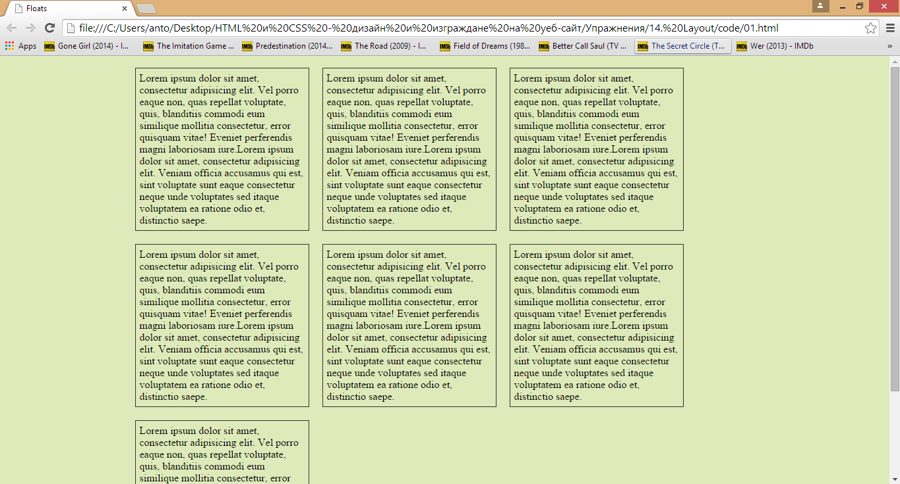

1. Layout2

